The Islamia University of Bahawalpur
Department of Information Technology

SOFTWARE REQUIREMENTS SPECIFICATION
(SRS DOCUMENT)
for
Restaurant Management System
with Card Payment Integration
Version 1.0
By
MUHAMMAD HANZLA
Roll No: S23BINFT1E02004
Session 2023 – 2027
Supervisor
Dr. MUSARAT KARIM
Bachelor of Science in Information Technology

Table of Contents
Contents
Purpose 1
Scope 1
Product Perspective 1
Operating Environment 1
User Classes 2
Constraints 2
Techniques Used 2
Use Case: Place a Customer Order (UC-1) 3
Use Case: Process Card Payment (UC-2) 4
Use Case: Manage Menu Items (UC-3) 4
Table Management 4
Menu Management 5
Order Management 5
Billing and Payment 5
Reservation, Inventory and Staff 7
Reports and Dashboard 7
Usability 8
Performance 8
Reliability 8
Security 8
Maintainability 9
Compatibility 9

Revision History
Date | Description | Author | Comments
29/04/2026 | Version 1.0 | Muhammad Hanzla | Initial Draft

Document Approval
The following Software Requirements Specification has been accepted and approved by the following:
Signature | Printed Name | Title | Date
 | Dr. Musarat Karim | Supervisor, IT Department

1. Introduction of the Project

Purpose
This document describes the software requirements for a Restaurant Management System with Card Payment Integration, designed as a website application. It is written for the development team, project supervisor, and academic evaluators.

Scope
The Restaurant Management System (RMS) is a web-based application that manages all restaurant operations digitally — from customer table booking and food ordering to billing and card payment. No paper-based process is needed. Key features include:
- Table management and reservation via browser interface
- Digital menu with categories and prices, manageable from any browser
- Order placement by staff through the web dashboard
- Customer self-ordering via QR code that opens a web page on any browser
- Bill generation with tax and discount support
- Card payment (Visa, Mastercard) and cash payment
- Digital receipt delivery via email; printable receipt from browser
- Inventory and stock management through the admin web panel
- Staff accounts with role-based access controlled from the web
- Sales reports and admin dashboard accessible from any modern browser
2. Overall Description

Product Perspective
The RMS is a web-based system that replaces all manual restaurant processes. It consists of a single responsive website with role-specific views: Admin/Manager Panel, Waiter/Cashier Dashboard. All views connect to one central server and are accessible from any modern web browser on desktop or laptop. Card payments are handled through a third-party payment gateway (e.g., Stripe or HBL Pay).

Operating Environment
- The website runs on any modern web browser: Chrome, Firefox, Edge, or Safari (desktop/laptop).
- Admin and manager panels are optimized for widescreen (1280px and above).
- Kitchen Display view is accessible on any screen connected to the restaurant network via browser.
- Waiter/Cashier dashboard is accessible from any browser on a Windows POS terminal or desktop PC.
- Server runs on Linux with minimum 4 CPU cores and 8 GB RAM.
- The system operates on local Wi-Fi even without internet, except for card payment processing.

User Classes
Admin / Owner | Full control: menu, staff, reports, settings | Browser (any device) | Medium
Manager | Daily operations, reports, shift management | Browser (desktop/laptop) | Medium
Waiter / Cashier | Take orders, process bills and card payments | Browser (POS terminal) | Low
Customer | Place order via QR code (opens web page) | Browser (any device) | Low

Constraints
- Card payment must use a PCI-DSS compliant gateway — card numbers are never stored locally.
- All communication must use HTTPS (TLS encryption).
- The website must support printing receipts directly from the browser via the browser print dialog or a connected thermal printer using a local print service.
- Backend: Python (Django/Flask) or Node.js (Express). Frontend: React.js or Vue.js. Database: MySQL or PostgreSQL.
- The website must be responsive and functional on all major desktop browsers at 1280px width or wider.
3. Requirement Identifying Techniques

Techniques Used
- Use Case Analysis — to define how each user interacts with the website.
- Storyboarding — to map the full customer journey from table entry to payment.
- Interviews — with restaurant owners, waiters, and kitchen staff.
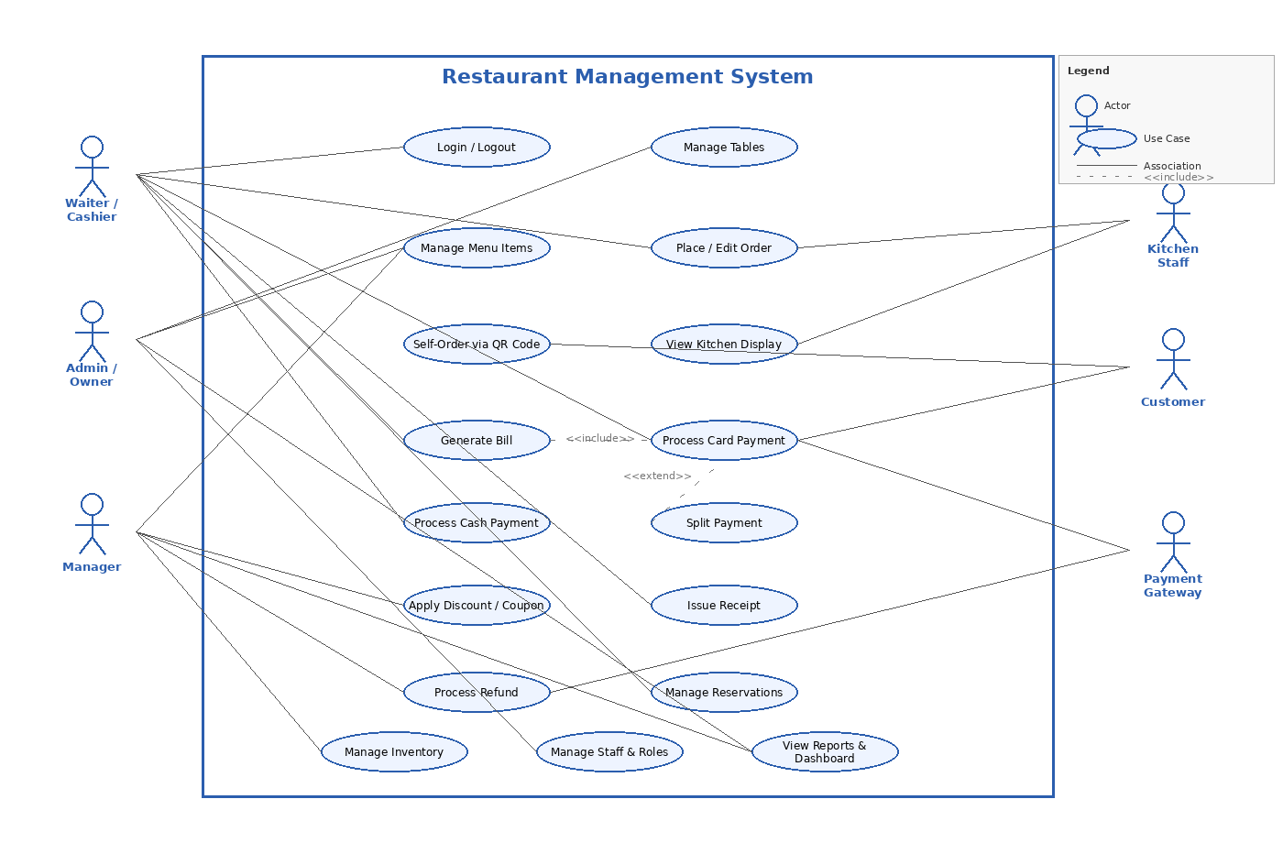
Figure 1: Use Case Diagram — Restaurant Management System

Use Case: Place a Customer Order (UC-1)
Use Case ID | UC-1
Actors | Waiter (primary), Kitchen Display System — web view (secondary)
Description | Waiter logs into the website, selects a table, picks items from the digital menu, and submits the order. Kitchen receives it instantly on the KDS web page.
Preconditions | Waiter is logged into the website. Table is occupied. Menu is configured in the admin panel.
Normal Flow | 1. Waiter opens the website dashboard. 2. Selects an occupied table. 3. Picks items and adds special instructions. 4. Submits the order via browser. 5. Order appears on the KDS web page with status Pending.
Exceptions | Item out of stock: system disables it automatically. Network down: order saved locally (browser) and synced when reconnected.
Priority | High

Use Case: Process Card Payment (UC-2)
Use Case ID | UC-2
Actors | Waiter/Cashier (primary), Payment Gateway (secondary)
Description | Cashier generates the bill on the website and the customer pays by card. System records the transaction and offers a printable/emailed receipt.
Preconditions | Table has at least one confirmed order. Payment gateway is online. Browser is open on the cashier dashboard.
Normal Flow | 1. Waiter clicks Generate Bill. 2. Website shows itemized bill with tax and total. 3. Waiter selects Card Payment. 4. Payment form opens in browser (redirected to gateway or embedded iframe). 5. Customer enters card details. 6. Gateway approves. 7. System saves transaction ID and offers printable/email receipt. 8. Table is reset to Available.
Exceptions | Card declined: cashier retries or switches to cash. Gateway timeout: retry once; if fails, manager overrides. No printer: receipt sent by email.
Priority | High

Use Case: Manage Menu Items (UC-3)
Use Case ID | UC-3
Actors | Admin / Manager
Description | Admin adds, edits, or removes menu items with name, category, price, and availability via the admin web panel.
Preconditions | Admin is logged in to the website with menu management permission.
Normal Flow | 1. Admin opens Menu Management page. 2. Selects a category (e.g., Starters, Main Course, Drinks). 3. Adds or edits an item with name, price, and image upload. 4. Toggles item as Available or Unavailable. 5. Changes instantly reflect on all waiter dashboards and the customer QR web page.
Priority | High

4. Functional Requirements

Table Management
ID | FR-1
Title | Table Layout and Status
Requirement | The website shall display a visual floor map of all tables on the dashboard. Each table shows its status: Available, Occupied, Reserved, or Needs Cleaning. Staff can update status with one click from any browser.
Priority | High

Menu Management
ID | FR-2
Title | Digital Menu
Requirement | The website shall maintain a digital menu with categories (Starters, Main Course, Drinks, Desserts, etc.). Each item has a name, price, image, and availability toggle. Admin changes via the web panel update instantly across all user dashboards.
Priority | High

ID | FR-3
Title | QR Code Self-Order
Requirement | Each table shall have a unique QR code. Customers scan it to open a web page on any browser, view the menu, and place an order directly without a waiter.
Priority | Medium

Order Management
ID | FR-4
Title | Place and Edit Orders
Requirement | Waiters can place orders for any table via the website, add or remove items, and add special instructions. Orders can be edited until submitted to the kitchen. After submission, only a manager can modify or cancel via the management panel.
Priority | High

Billing and Payment
ID | FR-5
Title | Bill Generation
Requirement | The website shall generate an itemized bill page showing each item, quantity, unit price, subtotal, tax (16% GST), discount if any, and total. The bill cannot be closed without a confirmed payment.
Priority | High

ID | FR-6
Title | Card Payment
Requirement | The website shall process Visa and Mastercard payments via a PCI-DSS compliant gateway embedded in the browser (iFrame or redirect). Only the transaction ID is saved. Every payment attempt is logged with timestamp and staff ID.
Priority | High

ID | FR-7
Title | Cash Payment
Requirement | The cashier enters the cash amount received on the website. The system calculates and displays the change to return to the customer.
Priority | High

ID | FR-8
Title | Split Payment
Requirement | A bill can be split between card and cash, or between multiple cards, directly from the website billing page. Each portion is processed and recorded separately.
Priority | Medium

ID | FR-9
Title | Discount and Coupon
Requirement | Managers can apply a percentage or fixed discount to any bill before payment via the website. Discount codes are configured in the admin web panel.
Priority | Medium

ID | FR-10
Title | Receipt — Print and Digital
Requirement | After payment, the website offers a printable receipt page (via browser print dialog). A digital receipt is also sent by email. The system logs receipt delivery status.
Priority | High

ID | FR-11
Title | Refund Processing
Requirement | Managers and admins can process full or partial refunds to the original card via the website management panel. A refund reason must be entered before processing.
Priority | Medium

Reservation, Inventory and Staff
ID | FR-12
Title | Table Reservation
Requirement | Staff can create, edit, and cancel reservations via the website. Each reservation records customer name, phone, date, time, party size, and table. Reserved tables are visually blocked on the floor map.
Priority | Medium

ID | FR-13
Title | Inventory and Stock Alerts
Requirement | The website tracks ingredient stock levels. When any item goes below the minimum threshold, an alert is shown on the manager dashboard. Menu items are automatically marked Unavailable when their ingredients run out.
Priority | Medium

ID | FR-14
Title | Staff Accounts and Roles
Requirement | The system supports four roles: Admin, Manager, Waiter, and Kitchen Staff, each with defined page access and permissions. Admins manage all accounts via the web admin panel.
Priority | High

Reports and Dashboard
ID | FR-15
Title | Sales Reports
Requirement | The website generates daily, weekly, and monthly sales reports showing revenue, number of orders, top-selling items, and card vs. cash breakdown. Reports can be exported as PDF or Excel directly from the browser.
Priority | High

ID | FR-16
Title | Admin Dashboard
Requirement | The admin web panel shows a real-time dashboard with today's sales, active tables, pending orders, low-stock alerts, and recent transactions. All data updates automatically without page refresh (live polling or WebSocket).
Priority | High

5. Non-Functional Requirements

Usability
- A waiter shall be able to place a complete order within 3 minutes on the website with no prior training.
- All clickable buttons shall be large enough to use comfortably on a POS terminal mouse or touchscreen (minimum 44x44 px).
- The website interface shall be available in English and Urdu, switchable from user settings.
- The website layout shall be optimized for desktop browsers at 1280px width or wider.

Performance
- An order submitted via the website shall appear on the KDS web page within 2 seconds.
- Bill generation on the website shall take no more than 3 seconds.
- The full card payment flow (from clicking Pay to confirmation on the website) shall complete within 30 seconds.
- The website shall handle at least 50 simultaneous active sessions without slowdown.
- All web pages shall load within 3 seconds on a standard broadband connection.

Reliability
- The website shall have 99% uptime during restaurant operating hours.
- If internet drops, the system keeps working on local Wi-Fi for all features except card payment.
- All data is backed up automatically at the end of each business day.
- The website shall handle session timeouts gracefully, redirecting to the login page without data loss for unsaved orders.

Security
- All staff must log in via the website with a username and password. Sessions expire after 30 minutes of inactivity.
- Card data is never stored on the server — only the transaction ID from the payment gateway is saved.
- The payment module must comply with PCI-DSS standards; card entry is handled via a secure hosted payment page or iframe.
- All web traffic between the browser and server uses HTTPS (TLS 1.2+).
- Every financial transaction is logged server-side with timestamp and staff ID for audit purposes.
- CSRF tokens and input validation are enforced on all website forms.

Maintainability
- Admin can update menu, prices, and table layout via the website without any code changes.
- Website updates can be deployed with less than 5 minutes of downtime.
- System logs are kept for at least 1 year for audit and troubleshooting.
- The website front-end and back-end shall be modular to allow independent updates.

Compatibility
- The website shall function correctly on Chrome (latest), Firefox (latest), Edge (latest), and Safari (latest) on desktop and laptop.
- The website shall not require any browser plugins or extensions.
- The website shall be accessible at a URL on the local network (LAN) and optionally over the internet via a domain name.

